Advanced Database Management Systems (CSC-234) Instructor: Hafiz Ahsan Atiq
Week:2 Marks: 10
CLOs | PLOs
1, 2, 3, 4 | 1, 2, 3, 4
Date: 17-Feb-2025 Time Allowed: 3 hrs
Objectives:
This lab activity aims to enhance students' understanding and practical skills in SQL operations, focusing on essential commands such as
- TRUNCATE
- BETWEEN
- ORDER BY
- GROUP BY
- UNION, & UNION ALL
Tools:
- MySQL (MySQL Workbench), PostgreSQL, Microsoft SQL Server,
- Oracle, SQLite, Xampp

Customers Table:

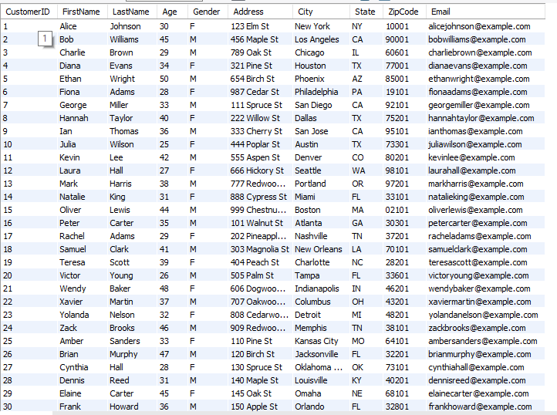

  - Create Table on the basis of table and data given above. Data types and size have to be decided by you and may vary.
  - Also Insert data into table as described above.
  - Write an SQL query to remove all data from the Customers table but keep the structure intact.
  - What is the key difference between TRUNCATE and DELETE?
  - Write an SQL query to find customers aged between 25 and 45.
  - Retrieve customers whose Zip Code falls between '10000' and '50000'.
  - Get a list of customers with Customer Id between 10 and 20, ordered by LastName.
  - Write a query to find customers not in the age range of 30 to 50.
  - Retrieve all customers sorted by FirstName in ascending order.
  - Write a query to list customers sorted by Age in descending order.
  - Get all customers ordered first by State (ascending) and then by City (descending).
  - What happens if you use ORDER BY 2 DESC? Explain with an example.
  - Modify a query to sort customers by State, then Age (descending), then FirstName.
  - Write an SQL query to count the number of customers in each State.
  - Retrieve the average age of customers in each state.
  - Find out how many customers belong to each gender (M/F).
  - List all cities along with the total number of customers in each city.
  - What will happen if you try to use GROUP BY without an aggregate function like COUNT() or SUM()?
  - Write an SQL query to combine the list of all customers from California (CA) and New York (NY).
  - Retrieve all customers aged below 30 and all customers aged above 50 using UNION.
  - Write a query to display unique cities from the Customers table using UNION.
  - What happens if column counts in SELECT statements used in UNION do not match?
  - Why does UNION remove duplicates while UNION ALL does not? Explain with an example.
  - Write an SQL query to get customers from TX and TX again, and observe duplicate records.
  - Retrieve all customers aged below 30 and above 50 ensuring duplicates are not removed.
  - What happens when you use ORDER BY in a UNION ALL query? Where should it be placed?
  - Why is UNION ALL generally faster than UNION? Explain in terms of query execution.
  - What will happen if the columns in two SELECT statements used in UNION ALL have different data types?

Marking Criteria:
Criteria | Marks | Details
Table Creation & Data Insertion | 2 | Correct structure, appropriate data types, and successful insertion of data.
TRUNCATE vs DELETE | 1 | Correct query for TRUNCATE and proper explanation of differences.
BETWEEN Operator Queries | 1 | Correct use of BETWEEN for age, zip code, and customer ID ranges.
ORDER BY Clause Usage | 1 | Correct sorting in ascending/descending order, including multi-column sorting.
GROUP BY & Aggregate Functions | 2 | Correct application of COUNT(), AVG(), SUM(), and explanation of GROUP BY without aggregate functions.
UNION vs UNION ALL Queries | 2 | Proper implementation of UNION and UNION ALL, including understanding of duplicate removal and performance impact.
Conceptual Explanations | 1 | Correct explanations of ORDER BY in UNION ALL, column count mismatches, and data type mismatches in UNION queries.

